**Personalized Virtual Gifts**

**Project**

**40%**

**Due Date:** Mon 8 January 2018

**Part 1 (65%):** Forms and input validation/processing

Develop a web application that allows a user to donate to a charity/cause with the functionality (as outlined below)

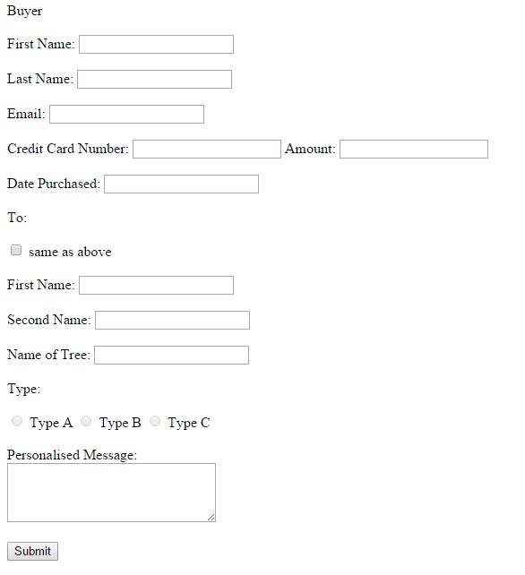

* **The form above should be tailored to fit your web application.**
* **JavaScript functions must be in an external file**
* **Enforce the following rules via JavaScript:** 
  + All fields (except the personalized) message should have a value.
  + Valid email address
  + Credit card number should be of the following format 9999-9999-99999999
    - Take in a number
      * Check for posn 3, 7 & 11 is –
      * All others follow regex
  + Date should be valid date in the format DD/MM/YYYY • Only one type should be able to be selected.
  + If the same as above check box is selected the first name and last name should be copied down
  + When the submit button is selected the user should be given a confirmation of all details entered.

**Part 2 (35%):** Java Script Animation / Enhancements on form

Example of enhancements – calendar widgets for selecting dates, tool tips, visual effects, draggable elements etc.

**Examples:**

**If a person donates a certain amount of money they can do one (or more) of the following:**

* + Name a Tree
  + Save a Tree
  + Add a star to the tree
  + Name a Star

Note – include instructions for the user to use the enhancements where relevant

# Note: It is mandatory to walkthrough your finished project